# Compass MED D - Medicare D Explanation of Benefits (EOB) Preferences (Regular Mail or Electronic)

[General Information](#_Toc189658172)

[View Medicare D EOB Preferences (Electronic or Standard Print Only)](#_Toc189658173)

[Edit Medicare D EOB Preferences from the Communication Screen (Electronic or Standard Print Only)](#_Toc189658174)

[Edit Medicare D EOB Preferences (Caremark.com)](#_Toc189658175)

[Confirm/Update Electronic EOB Email in ONEclick](#_Toc189658176)

[Electronic EOB Pop-up on Caremark.com](#_Toc189658177)

[Registering and Viewing Electronic EOBs and Paperless Documents directly from My Document Source](#_Toc189658178)

[EOB Guest Preview and Electronic Opt-in](#_Toc189658179)

[EOB 1 Click Electronic Preference Setting and Opt-in](#_Toc189658180)

[Electronic Email Campaign - Unsubscribe Feature](#_Toc189658181)

[Frequently Asked Questions (FAQs)](#_Toc189658182)

[Related Documents](#_Toc189658183)

**Description:** This document outlines steps for viewing, adding, editing, and opting in/out Medicare D EOB Preferences.

|  |
| --- |
| General Information |

When MED D beneficiaries for electronic EOB clients call into MED D Customer Care, beneficiaries will be allowed to opt into receiving electronic EOBs.

* Beneficiaries can call to **opt in** to receive electronic EOBs at any time.
* Beneficiaries can call to **opt out at any time** if they had previously opted in (via Care, Portal).

 If beneficiary wants to opt into electronic EOBs, CCRs should follow the steps in Compass. However, if the beneficiary wants to enroll themselves in electronic EOB’s or other documents later, CCRs should assist the beneficiary through the [Edit Medicare D EOB Preferences (Caremark.com)](#_Edit_Medicare_D) process outlined below.

Electronic EOBs are available for a variety of Medicare D clients who have opted into the program. Refer to CIF.

**Note:** The list of installed clients is ever-changing and not all clients manage their EOBs and preferences on Caremark.com.

 Outbound Interactive Voice Response (IVR) Call Campaigns are also conducted through Welltok (a third-party vendor dialer program), to educate SilverScript beneficiaries about their option to receive their EOBs online by registering to receive their EOBs electronically.

[Top of the Document](#_top)

|  |
| --- |
| View Medicare D EOB Preferences (Electronic or Standard Print Only) |

The CCR should perform the following to view EOB preference:

|  |  |  |
| --- | --- | --- |
| **Step** | **Action** | |
| **1** | From the Member Snapshot Landing Page, navigate to the **Quick Actions** panel, then click the **Communications** hyperlink.        **Result:** The Communications screen will display the following:   * Communications Quick Links * Communication History * Search for Communication * Medicare D EOB Preference     **Notes:**     * To add, edit, or delete a member’s EOB preference, open an **Interaction Case**. * Research Cases do not allow EOB preference updates. | |
| **2** | Navigate to **Medicare D EOB Preference**section to view the beneficiary’s EOB preference for Electronic or Standard print.  When clicking EOB Preference field, a check mark will display next to option member is enrolled. | |
| **EOB Preference Types:** | **Description:** |
| Audio CD | **Do not use.**  Refer to [Compass MED D - Member Resource Orders (Fulfillment Request)](https://thesource.cvshealth.com/nuxeo/thesource/#!/view?docid=3a2c4b14-9101-4e14-8221-652e4e6b5b8a). |
| Braille | **Do not use.**  Refer to [Compass MED D - Member Resource Orders (Fulfillment Request)](https://thesource.cvshealth.com/nuxeo/thesource/#!/view?docid=3a2c4b14-9101-4e14-8221-652e4e6b5b8a). |
| Data CD | **Do not use.**  Refer to [Compass MED D - Member Resource Orders (Fulfillment Request)](https://thesource.cvshealth.com/nuxeo/thesource/#!/view?docid=3a2c4b14-9101-4e14-8221-652e4e6b5b8a). |
| Electronic | The EOB is received via email.    **Note:**  Electronic EOBs are sent to the default email address. To add/update the email address on the Member Snapshot Landing Page and the Medicare D Landing Page, refer to [Compass MED D - Email and Phone Number Changes](https://thesource.cvshealth.com/nuxeo/thesource/#!/view?docid=5888e5ed-52cf-4716-bd08-ebe95bd10a46) and [Compass - Add / Edit / Delete Email Address](https://thesource.cvshealth.com/nuxeo/thesource/" \l "!/view?docid=e01087c4-421c-4330-bcb3-81cb8cb45762" \t "_blank). |
| Large Print | **Do not use.**  Refer to [Compass MED D - Member Resource Orders (Fulfillment Request)](https://thesource.cvshealth.com/nuxeo/thesource/#!/view?docid=3a2c4b14-9101-4e14-8221-652e4e6b5b8a). |
| Standard | The EOB is received via mail.    **Note:**  The EOB Preference will default to Standard if the beneficiary has not specified their EOB preference type. |

[Top of the Document](#_top)

|  |
| --- |
| Edit Medicare D EOB Preferences from the Communication Screen (Electronic or Standard Print Only) |

**Note:** In order to receive electronic EOBs, the beneficiary must have an email address on file in Compass. To add/update the email address on the Member Snapshot Landing Page and the Medicare D Landing Page, refer to [Compass MED D - Email and Phone Number Changes](https://thesource.cvshealth.com/nuxeo/thesource/" \l "!/view?docid=5888e5ed-52cf-4716-bd08-ebe95bd10a46) and [Compass - Add / Edit / Delete Email Address](C:\\Users\\C337799\\Downloads\\TSRC-PROD-053409).

The EOB Preference will default to Standard if the beneficiary has not specified their EOB preference type.

The CCR should perform the following to update EOB preferences:

|  |  |  |  |
| --- | --- | --- | --- |
| **Step** | **Action** | | |
| **1** | View current beneficiary EOB Preferences, refer to [View Medicare D EOB Preferences](#_View_Medicare_D). | | |
| **2** | Click the **EOB Preference** drop-down menu and select either **Standard** or **Electronic**. | | |
| **If EOB Preference is…** | **Action…** | |
| Standard (Regular Mail) | Confirm the address the beneficiary would like the EOB mailed to. | |
| **If…** | **Then…** |
| Current address on file | Select **Standard** and proceed to the next step. |
| New address | * Update the address, as appropriate, in Compass. Refer to:   + [Compass MED D - Address Changes and Out of Area (OOA)](https://thesource.cvshealth.com/nuxeo/thesource/#!/view?docid=a5cf7af0-8a89-45dc-a395-9961dceac183)   + [Compass - Add / Edit / Delete Mailing Address](file:///C:\Users\C337799\AppData\Local\Microsoft\Windows\INetCache\Content.Outlook\U1QX4D53\TSRC-PROD-053255) * Proceed to the next step. |
| Electronic (E-mail) | Confirm the email address displayed is correct. | |
| **If…** | **Then…** |
| Yes | Proceed to the next step. |
| No | * If the email address is **not** on file, the following error message will display: “Obtain Email Address.” The Save button will be disabled. Add an email address to the beneficiary’s account. * If the email address displayed is incorrect, update the beneficiary’s email address.   **Note:** To update the email address on the Member Snapshot Landing Page and the Medicare D Landing Page, refer to [Compass MED D - Email and Phone Number Changes](https://thesource.cvshealth.com/nuxeo/thesource/#!/view?docid=5888e5ed-52cf-4716-bd08-ebe95bd10a46) and [Compass - Add / Edit / Delete Email Address](file:///C:\Users\C337799\Downloads\TSRC-PROD-053409).   * Once email updates have been completed, return to this section to update Electronic EOB preferences. |
| Accessible Formats and Non-English Languages.   * Audio CD * Braille * Data CD * Large Print | A Support Task will need to be submitted. Refer to [Compass MED D - Member Resource Orders (Fulfillment Request)](https://thesource.cvshealth.com/nuxeo/thesource/#!/view?docid=3a2c4b14-9101-4e14-8221-652e4e6b5b8a). | |
| **3** | Click **Save.**  **Result:** Message will display EOB Preference successfully updated. | | |

[Top of the Document](#_top)

|  |
| --- |
| Edit Medicare D EOB Preferences (Caremark.com) |

To receive Electronic EOBs, the beneficiary must have an email address on file in Compass. Refer to [Compass MED D - Email and Phone Number Changes](https://thesource.cvshealth.com/nuxeo/thesource/#!/view?docid=5888e5ed-52cf-4716-bd08-ebe95bd10a46) and [Compass - Add / Edit / Delete Email Address](C:\\Users\\C337799\\Downloads\\TSRC-PROD-053409).

The default print format for paper EOBs is standard.

The CCR should perform the steps below:

|  |  |  |  |
| --- | --- | --- | --- |
| **Step** | **Action** | | |
| **1** | From the **Quick Action** panel on the Member Snapshot Landing Page, verify the beneficiary is currently enrolled to Caremark.com.   * Next to the **Caremark.com** link, you can view the status of the member’s Caremark.com account: * Registered * Inactive Winback with an info icon that displays the following message: “Account is locked after 6 months of inactivity.” * Not Registered * Registration Unknown | | |
| **If beneficiary...** | | **Then…** |
| Does have a Caremark.com account | | **Do you have an access to your Caremark.com account?** Great! It will only take a minute to request the change. You already have access to up to 36 months of your EOB history to your Caremark.com account and you can begin to access them immediately. Once we’ve processed your EOB request, you will receive an email each time a new online EOB has been added to your account. If at any time you wish to opt-out of Electronic statements, you can change your preferences in your Caremark.com account profile.  **Proceed to the next step**. |
| Does **not** have a Caremark.com account | | Proceed to Quick Registration Workflow in [Compass - Caremark.com Quick Registration](https://thesource.cvshealth.com/nuxeo/thesource/#!/view?docid=0b9a88e0-b8ac-472a-925b-dfc9e016614a). |
| **2** | You will need to access your **Caremark.com** account. | | |
| **3** | From Caremark.com, click **Profile** at the top of the page.    **Result:** The Profile page will display. | | |
| **4** | From the Profile page, click **Communication preferences.** | | |
| **5** | Scroll down to Paperless settings,then click **Edit.** | | |
| **6** | Click **Show all available documents** to expand the section. | | |
| **7** | Determine the type of EOB preference update the beneficiary would like to make. | | |
| **If…** | **Then…** | |
| Opt Into Electronic EOB | If the box next to **Explanation of benefits (EOB) info** is **unchecked**, the beneficiary is currently receiving paper EOB by mail.    To opt into receiving electronic EOBs:   * Check the box next to **Explanation of benefits (EOB) info**. * Click the **Save changes** button. | |
| Opt Out of Electronic EOB | If the box next to **Explanation of benefits (EOB) info** is **checked**, the beneficiary is currently receiving electronic EOB.  To opt out of receiving electronic EOBs:   * Uncheck the box next to **Explanation of benefits (EOB) info**. * Click the **Save changes** button. | |
| EOB in an accessible format (Braille, Large Print) or non-English language | If the beneficiary would like to receive their paper EOB by mail in an accessible format or non-English language:  Refer to [Compass MED D - Member Resource Orders (Fulfillment Request)](https://thesource.cvshealth.com/nuxeo/thesource/#!/view?docid=3a2c4b14-9101-4e14-8221-652e4e6b5b8a) | |

[Top of the Document](#_top)

|  |
| --- |
| Confirm/Update Electronic EOB Email in ONEclick |

 If the beneficiary did not have any prescription activity during the month in question, they would not receive an EOB.

If the beneficiary advises that they opted-in to Electronic EOB but did not receive the monthly email or they need to update their email, perform the following steps:

|  |  |  |
| --- | --- | --- |
| **Step** | **Action** | |
| **1** | From the Member Snapshot Landing Page, navigate to the **Quick Actions** panel then click **Communications.** | |
| **2** | Click the **Other Member Letters** hyperlink from the **Communications Quick Links** section:    **Result:** ONEclick opens in new window. | |
| **3** | Click **Manage Preferences** to confirm the email address for the beneficiary.  **Note:** If **Email Failed** text appears beside the MemberID, a hardcopy is automatically sent to the beneficiary.    **Result:** A pop-up window displays. | |
| **If the email address is…** | **Then...** |
| Incorrect | Click **Edit** and enter the correct email address, then click the **Submit** button. |
| Correct | Click **Cancel** to close the pop-up window without making changes**.** |
| **4** | Confirm the correct email address is on file in Compass. Refer to [Compass MED D - Email and Phone Number Changes](https://thesource.cvshealth.com/nuxeo/thesource/#!/view?docid=5888e5ed-52cf-4716-bd08-ebe95bd10a46) and [Compass - Add / Edit / Delete Email Address](file:///C:\Users\C337799\Downloads\TSRC-PROD-053409). | |

[Top of the Document](#_top)

|  |
| --- |
| Electronic EOB Pop-up on Caremark.com |

If a beneficiary who is not opted in for electronic/electronic EOBs logs in to Caremark.com, they may be presented with the pop-up shown below, offering the electronic EOB option.

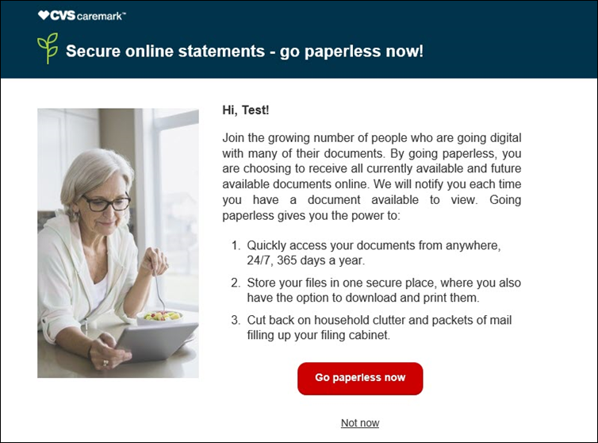

The CCR should perform the following if the electronic EOB window pops up on Caremark.com:

|  |  |
| --- | --- |
| **If the beneficiary says…** | **Then…** |
| Yes | * Click **Go paperless now**. * You should now be enrolled in Electronic EOBs. |
| No | * Click **Not Now**. * The window will close, and you should now be on the Caremark.com dashboard.   **Note:** An optional survey opportunity regarding electronic options will display for some users. The pop-up window will no longer show to the beneficiary for 30-90 days (this setting varies). |

[Top of the Document](#_top)

|  |
| --- |
| Registering and Viewing Electronic EOBs and Paperless Documents directly from My Document Source |

Refer to [Caremark.com – Electronic EOB’s and Paperless Documents (MED-D)](C:\\Users\\C337799\\Downloads\\TSRC-PROD-050504).

[Top of the Document](#_top)

|  |
| --- |
| EOB Guest Preview and Electronic Opt-in |

Beneficiaries can use the EOB Guest Preview when they receive an email alert. The beneficiary will need to verify their identity by entering their date of birth and their member ID.

Beneficiary does not need to be registered to preview their EOBs on Caremark.com.

**Result:** The Beneficiary EOB page and EOBs will display. The page will contain an electronic option to opt-in.

* If the beneficiary opts-in, they will be presented with further instructions to register an account and/or update communication preference, pending registration status. Confirmation text advises beneficiaries it may take up to 2 months to receive first electronic EOBs as well as capability to change preference back to paper at any time.

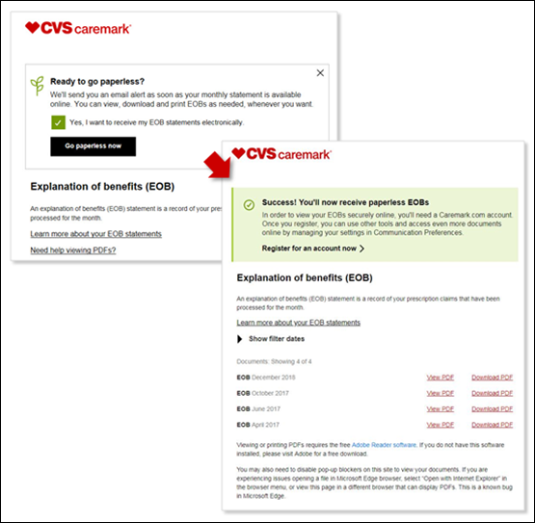

[Top of the Document](#_top)

|  |
| --- |
| EOB 1 Click Electronic Preference Setting and Opt-in |

Beneficiaries may receive an email that allows them to easily opt-in to electronic EOBs by a simple click on **Go electronic now.** The beneficiary will be directed to the Caremark.com landing page confirming preference for EOBs has been set. It will provide further instructions to register an account and/or update communication preference, pending registration status. Beneficiary is advised it may take up to 2 months to receive first electronic EOBs as well as capability to change preference back to paper at any time.

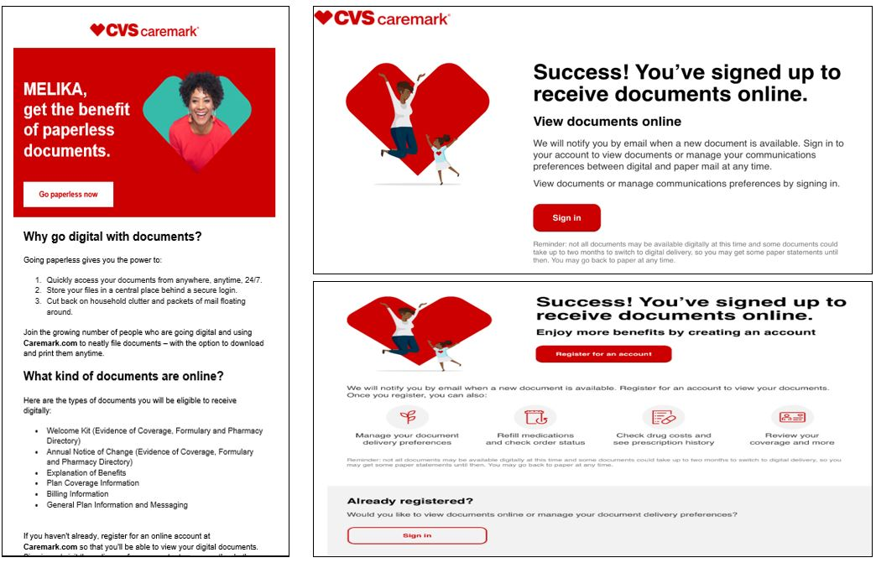

[Top of the Document](#_top)

|  |
| --- |
| Electronic Email Campaign - Unsubscribe Feature |

Email campaigns provide an unsubscribe feature allowing beneficiaries (registered or unregistered) to unsubscribe from the specific campaign and receive no further emails. Currently the feature is campaign-specific only. There is not an option to manage a global preference for adoption emails or electronic emails.

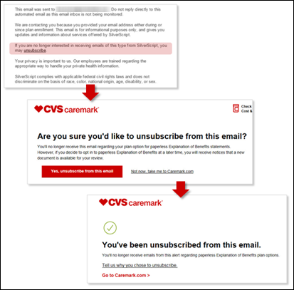

[Top of the Document](#_top)

|  |
| --- |
| Frequently Asked Questions (FAQs) |

Refer to the following FAQs as needed:

|  |  |
| --- | --- |
| **Question** | **Answer** |
| 1. **What are the benefits of switching to electronic EOBs?** | * With electronic Explanation of Benefits (EOB) statements, you can access your information online at any time, rather than waiting to receive a paper version by mail. * We will send you an email as soon as a new EOB is ready to view. * Electronic EOBs help you stay organized and ensure your personal health information remains secure with no shredding necessary. * Up to 36 months of your EOBs are stored safely in a password-protected online account and organized by date so you can quickly find the statement you need. * You can access your statements at any time, and print only those you need, which can reduce paper clutter. * Since your statements are online, you can access them anywhere – at the pharmacy, at your doctor’s office – even when travelling. |
| 1. **Can I view my EOBs online even if I am not an electronic beneficiary?** | Yes – any beneficiary with a Caremark.com account can view, print, or download up to 36 months of EOBs online. |
| 1. **Can I switch back to Paper Statements?** | Yes – You can switch back to receiving paper statements at any time by changing your profile in your Caremark.com account or calling Customer Care. |
| 1. **How will I know my EOB is available?** | * You will receive an email notifying you that a new EOB is available to view online. * If the email fails and CVS Caremark is notified of the failure, a paper copy email of your EOB will be mailed prior to the end of the month. |
| 1. **When will I be able to see my EOBs online once I sign up?** | * Up to 36 months of your EOB history has already been loaded into your Caremark.com account, and you can login and see those immediately. * New EOBs will typically be available by the 20th of each month after you use your coverage.   **Example:** Beneficiary fills a prescription in July. By August 20th, they should receive an email letting them know they have a new EOB available to view online. |
| 1. **Is this functionality available for the Caremark app or mobile site?** | Yes, you can also access your EOBs on the Caremark.com Mobile Site via your phone or other device, however this feature is not available in the Caremark App at this time. |
| 1. **How far back can I go to obtain EOB statements?** | Many beneficiaries can see up to 36 months of EOB history across Caremark PBM plans. |
| 1. **What if the eEOB functionality is not available when I log in?** | I’ll need to submit a request to research this issue. The Web Support Team will be contacting you with a resolution. Are there any benefit issues I can assist you with?  **CCR Process Note:** Refer to   * [Caremark.com – Web Error Form Process (Commercial and MED-D)](file:///C:\Users\C337799\Downloads\TSRC-PROD-041424) * [Caremark.com - Web Error Form Process (Vendor Teams Only)](file:///C:\Users\C337799\Downloads\TSRC-PROD-046777) |
| 1. **Why do I have to provide my Email address?** | * We will use your email address to send a notification when a new EOB is available to view online. * If we are unable to deliver an email to the address on record, you will still be able to access your EOB online but will also receive a printed copy in the mail. |
| 1. **I see a pop-up notice about electronic EOBs every time I login to my Caremark.com account. Is there any way to stop this from happening?** | * The pop-up is automated and designed to make it easier to choose electronic Explanation of Benefits statements, should you decide to switch in the future. * If you do not wish to choose electronic EOBs, simply click the Not now button, and the pop-up will disappear from the screen and be delayed from showing for 30 days or more. |
| 1. **If I opt out of electronic EOBs on the 19th of the month, do I still receive another electronic EOB on the 20th or is that opt out effective immediately and I’ll be sent a paper copy?** | * If you opt out of electronic EOBs on the 1st of the month you will still receive an electronic EOB for that month. * You will not be mailed a paper one until the next month’s mailing.   **Example:** You opt out on March 2nd; you will receive an eEOB for March and then receive a paper copy in the mail for April. |
| 1. **If it’s not immediate, how many days prior to the 20th would the I need to opt out of electronic EOBs in order to receive a paper copy in the mail for that month?** | * EOB statements and data are consolidated the first day of each month, for the previous month’s prescriptions. * Paper vs. eEOB preferences must be updated by the end of the month (30th or 31st) to be made in time for the following month.   **Example:** You change back to paper preference on January 31st, you will receive a paper EOB for February. |
| 1. **What if there are issues with the eEOB website?** | I’ll need to submit a request to research this issue. The Web Support Team will be contacting you with a resolution. Are there any benefit issues I can assist you with?  **CCR Process Note:** Refer to   * [Caremark.com – Web Error Form Process (Commercial and MED-D)](file:///C:\Users\C337799\Downloads\TSRC-PROD-041424) * [Caremark.com - Web Error Form Process (Vendor Teams Only)](file:///C:\Users\C337799\Downloads\TSRC-PROD-046777) |
| 1. **I would like to receive my EOB in an accessible format or a non-English language.** | Refer to [Compass MED D - Member Resource Orders (Fulfillment Request)](https://thesource.cvshealth.com/nuxeo/thesource/#!/view?docid=3a2c4b14-9101-4e14-8221-652e4e6b5b8a). |

[Top of the Document](#_top)

|  |
| --- |
| Related Documents |

**Parent SOP:** CALL-0048: [Medicare Part D Customer Care Call Center Requirements-CVS Caremark Part D Services, L.L.C.](https://policy.corp.cvscaremark.com/pnp/faces/SecureDocRenderer?documentId=CALL-0048&uid=pnpdev1)

**Abbreviations/Definitions:** [Abbreviations / Definitions](file:///C:\Users\C337799\Downloads\CMS-2-017428)

[Top of the Document](#_top)

Not To Be Reproduced Or Disclosed to Others Without Prior Written Approval

**ELECTRONIC DATA = OFFICIAL VERSION / PAPER COPY = INFORMATIONAL ONLY**